**Assignment -1**

**Arduino Uno-3 Programming**

|  |  |
| --- | --- |
| Assignment Date | 15 September 2022 |
| Student Name | M. Suryakumar |
| Student Roll Number | 912419104033 |
| Maximum Marks | 2 Marks |

**Question-1:**

**Alarm should sound in one manner temperature is above 60degree C.**

**Solution:**

**CODING FOR CIRCUIT**

void setup()

{

Serial.begin(9600);

pinMode(6,OUTPUT);

}

void loop()

{

int data=analogRead(A2);

double n=data/1024;

double volt=n*6;

double off=volt-0.6;

double temperature=off*100;

Serial.print(“Temperature data..”);

Serial.println(temperature);

tone(5,100);

delay(2000)**;**

tone(5,200);

delay(2000);

**}**

**Circuit diagram:**

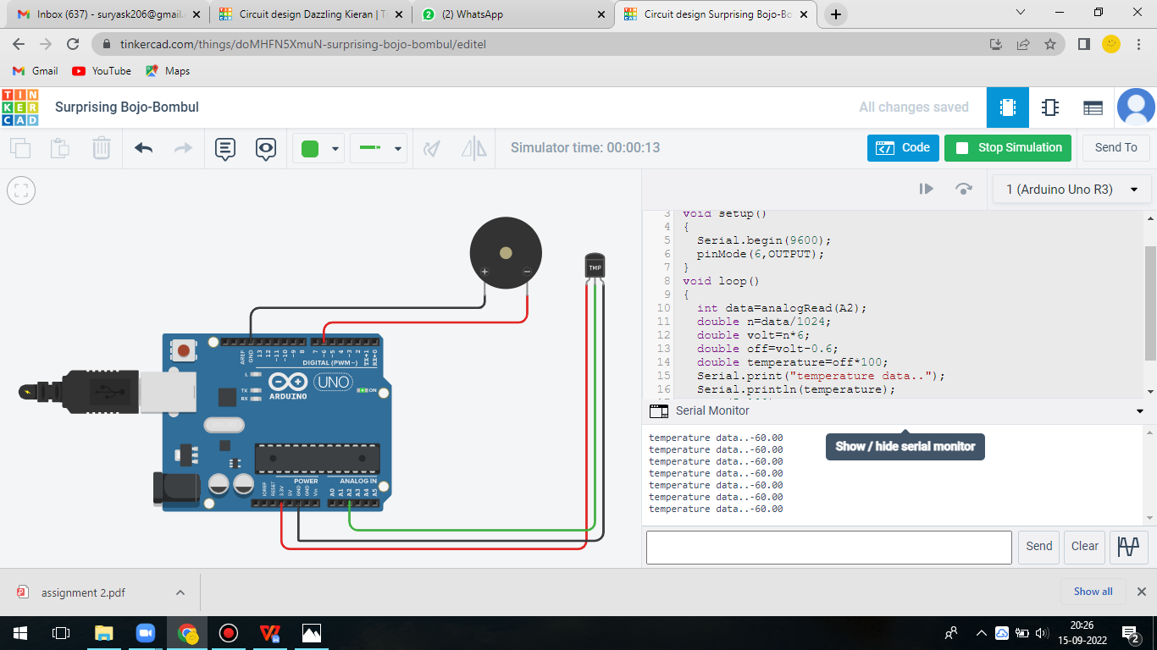

**Question-2:**

**Alarm should sound with another frequency if motion is detected in PIR sensor.**

**Solution:**

**CODING FOR CIRCUIT**

void setup()

{

pinMode(2,INPUT);

pinMode(12,OUTPUT);

}

void loop()

{

if(digitalRead(2)==HIGH)

{

digitalWrite(12,HIGH);

}

else

{

digitalWrite(12,LOW);

}

delay(2000); // Wait for 2000 milliseconds

}

**Circuit diagram:**

